

**ROCKBUSTER**

**STEALTH**

**ENTERTAINMENT LLC.**

DATA DICTIONARY

**Table of Contents**

* 1. Table of Contents ...............................................................................................2
  2. Legend ...............................................................................................................3

2.1 Rockbuster Entity Relationship Diagram (ERD) .................................................4

3. Facts Tables:

3.1 Rental ....................................................................................................5

3.2 Payment................................................................................................6

3.3 Inventory ...............................................................................................6

3.4 Store .....................................................................................................7

3.5 Film .......................................................................................................7

3.6 Film Category.........................................................................................8

3.7 Category ................................................................................................8

3.8 Language................................................................................................9

3.9 Actor .....................................................................................................9

3.10 Film Actor .........................................................................................10

3.11 Customer...........................................................................................10

* 1. Staff ..................................................................................................11

3.13 Address..............................................................................................12

3.14 City.....................................................................................................13

3.15 Country .............................................................................................13

* 1. **LEGEND**

|  |  |
| --- | --- |
|  | PRIMARY KEY |
|  | FOREIGN KEY |
|  | COMPOSITE KEY |
|  | LINKED TO |
|  | LINKED FROM |
|  | LINKED WITH |

**2.1 Rockbuster Entity Relationship Diagram (ERD)**

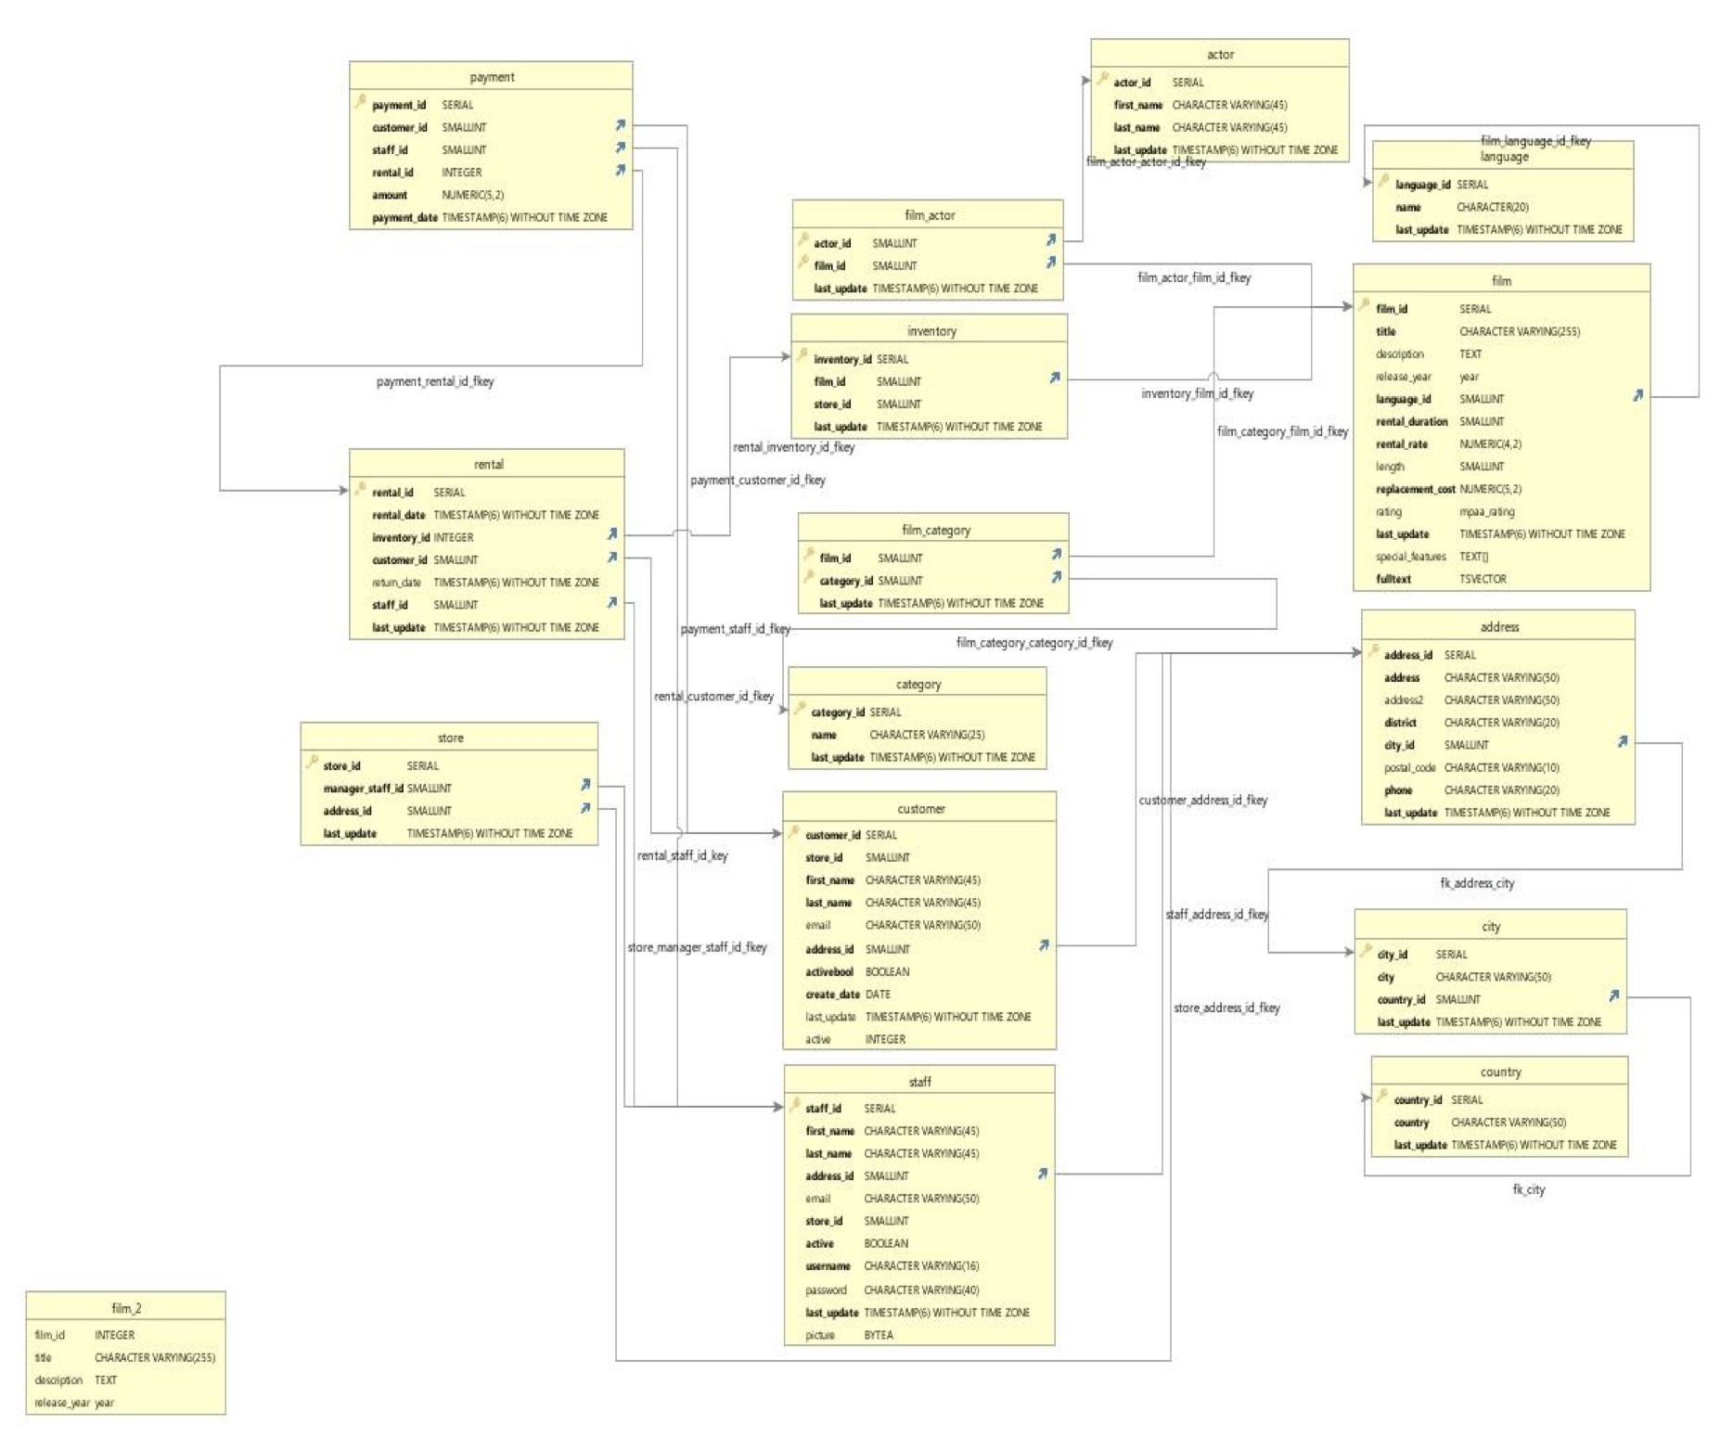

**3.1 RENTAL**

|  |  |  |  |
| --- | --- | --- | --- |
| Key | Columns | Data Type | Description |
|  | rental_id | SERIAL | Primary key for rental record. Number assigned to rental |
|  | rental_date | TIMESTAMP(6) WITHOUT TIMEZONE | Date of rental |
|  | inventory_id | INTEGER | Number assigned to item Date rental was returned |
|  | customer_id | SMALLINT | Number assigned to customer |
|  | return_date | TIMESTAMP(6) WITHOUT TIMEZONE | Date rental was returned |
|  | staff_id | SMALLINT | Number assigned to employee checking out customer |
|  | last_update | TIMESTAMP(6) WITHOUT TIMEZONE | Date entry was last updated |

Linked to:

|  |  |  |  |
| --- | --- | --- | --- |
| KEY | TABLE | Key Type | Join |
|  | inventory | Foreign | rental.inventory.id=inventory.inventory_id |
|  | customer | Foreign | rental.customer_id=customer.customer_id |
|  | staff | Foreign | rental.staff_id=staff.staff_id |

Linked from:

|  |  |  |  |
| --- | --- | --- | --- |
| KEY | TABLE | Key Type | Join |
|  | payment | Primary | payment.rental_id=rental.rental_id |

**3.2 PAYMENT**

|  |  |  |  |
| --- | --- | --- | --- |
| Key | Columns | Data Type | Description |
|  | payment_id | SERIAL | Primary key for payment records. Identity value for payment |
|  | customer_id | SMALLINT | Identity value for customers |
|  | staff_id | SMALLINT | Identity value for staff |
|  | rental_id | INTEGER | Identity value for film rental |
|  | amount | NUMERIC(5,2) | Monetary amount of payment |
|  | payment_date | TIMESTAMP(6) WITHOUT TIMEZONE | Date/time of payment |

Linked to:

|  |  |  |  |
| --- | --- | --- | --- |
| KEY | TABLE | Key Type | Join |
|  | rental | Foreign | payment.rental=rental.rental_id |
|  | customer | Foreign | payment.customer_id=customer.customer_id |
|  | staff | Foreign | payment.staff_id=staff.staff_id |

**3.3 INVENTORY**

|  |  |  |  |
| --- | --- | --- | --- |
| Key | Column | Data Type | Description |
|  | inventory_id | SERIAL | Primary key for inventory records. Number assigned to item |
|  | Film_id | SMALLINT | Number assigned to film |
|  | Store_id | SMALLINT | Number assigned to store |
|  | last_update | TIMESTAMP(6) WITHOUT TIMEZONE | Date entry was last updated |

Linked to:

|  |  |  |  |
| --- | --- | --- | --- |
| KEY | TABLE | Key Type | Join |
|  | Film | Foreign | inventory.film_id = film.film_id |

Linked from:

|  |  |  |  |
| --- | --- | --- | --- |
| KEY | TABLE | Key Type | Join |
|  | rental | Primary | rental.inventory_id=inventory.inventory_id |

**3.4 STORE**

|  |  |  |  |
| --- | --- | --- | --- |
| Key | Column | Data Type | Description |
|  | store_id | SERIAL | Primary key for store records. Number assigned to store |
|  | manager_staff_id | SMALLINT | Number assigned to store manager |
|  | address_id | SMALLINT | Number assigned to store address |
|  | last_update | TIMESTAMP(6) WITHOUT TIMEZONE | Date entry was last updated |

Linked to:

|  |  |  |  |
| --- | --- | --- | --- |
| KEY | TABLE | Key Type | Join |
|  | staff | Foreign | store.manager_staff_id=staff.staff_id |
|  | address | Foreign | store.address_id=address.address_id |

**3.5 FILM**

|  |  |  |  |
| --- | --- | --- | --- |
| Key | Column | Data Type | Description |
|  | film_id | SERIAL | Primary key for film records. Number assigned to film |
|  | title | CHARACTERVARYING(255) | Title of film |
|  | description | TEXT | Description of film |
|  | release_year | year | Release year of film |
|  | language_id | SMALLINT | Number assigned to language of film |
|  | rental_duration | SMALLINT | Length of film rental |
|  | rental_rate | NUMERIC(4,2) | Price of film rental |
|  | length | SMALLINT | Length of film |
|  | replacement_cost | NUMER(5,2) | Cost to replace film |
|  | rating | mpaa_rating | Film rating |
|  | last_update | TIMESTAMP(6) WITHOUT TIMEZONE | Date entry was last updated |
|  | special_features | TEXT[] | Special features included with film |
|  | fulltext | page4image2184968480TSVECTOR | Keywords associated with film |

Linked to:

|  |  |  |  |
| --- | --- | --- | --- |
| KEY | TABLE | Key Type | Join |
|  | language | Foreign | Film.language_id = language.language_id |

Linked from:

|  |  |  |  |
| --- | --- | --- | --- |
| KEY | TABLE | Key Type | Join |
|  | inventory | Primary | inventory.film_id = film.film_id |
|  | film_category | Primary | film_category.film_id=film.film_id |
|  | film_actor | Primary | film_actor.film_id=film.film_id |

**3.6 FILM CATEGORY**

|  |  |  |  |
| --- | --- | --- | --- |
| Key | Columns | Data Type | Description |
|  | film_id | SMALLINT | Number assigned to film |
|  | category_id | SMALLINT | Number assigned to genre |
|  | last_update | TIMESTAMP(6) WITHOUT TIMEZONE | Date entry was last updated |

Linked to:

|  |  |  |  |
| --- | --- | --- | --- |
| KEY | TABLE | Key Type | Join |
|  | film | Primary, Foreign | Film_category.film_id = film.film_id |
|  | category | Primary, Foreign | Film_category.category_id = category.category_id |

**3.7 CATEGORY**

|  |  |  |  |
| --- | --- | --- | --- |
| Key | Columns | Data Type | Description |
|  | category_id | SERIAL | Primary key for category records. Number assigned to genre |
|  | name | CHARACTER(25) | Name of genre |
|  | last_update | CHARACTER(25) | Date entry was last updated |

Linked From:

|  |  |  |  |
| --- | --- | --- | --- |
| KEY | TABLE | Key Type | Join |
|  | customer | Primary | Film_category.category_id = category.category_id |

**3.8 LANGUAGE**

|  |  |  |  |
| --- | --- | --- | --- |
| Key | Columns | Data Type | Description |
|  | language_id | SERIAL | Primary key for language records. Number assigned to language |
|  | name | CHARACTER(20) | Name of language |
|  | last_update | TIMESTAMP(6) WITHOUT TIMEZONE | Date entry was last updated |

Linked From:

|  |  |  |  |
| --- | --- | --- | --- |
| KEY | TABLE | Key Type | Join |
|  | film | Primary | film.language_id = language.language_id |

**3.9 ACTOR**

|  |  |  |  |
| --- | --- | --- | --- |
| Key | Columns | Data Type | Description |
|  | actor_id | SERIAL | Primary key for actor records. Number assigned to actor |
|  | First_name | CHARACTERVARYING(45) | First name of actor |
|  | Last_name | CHARACTERVARYING(45) | Last name of actor |
|  | last_update | TIMESTAMP(6) WITHOUT TIMEZONE | Date entry was last updated |

Linked From:

|  |  |  |  |
| --- | --- | --- | --- |
| KEY | TABLE | Key Type | Join |
|  | film_actor | Primary | film_actor.actor_id = actor.actor_id |

**3.10 FILM ACTOR**

|  |  |  |  |
| --- | --- | --- | --- |
| Key | Columns | Data Type | Description |
|  | actor_id | SMALLINT | Primary key for actor records. Number assigned to actor |
|  | film_id | SMALLINT | Number assigned to film |
|  | last_updaat | TIMESTAMP(6) WITHOUT TIMEZONE | Date entry was last updated |

Linked to:

|  |  |  |  |
| --- | --- | --- | --- |
| KEY | TABLE | Key Type | Join |
|  | actor | Primary, Foreign | Film_category.film_id = film.film_id |
|  | film | Primary, Foreign | Film_category.category_id = category.category_id |

**3.11 CUSTOMER**

|  |  |  |  |
| --- | --- | --- | --- |
| Key | Columns | Data Type | Description |
|  | customer_id | SERIAL | Primary key for customer records. Number assigned to customer |
|  | store_id | SMALLINT | Number assigned to store |
|  | first_name | CHARACTERVARYING(45) | First name of customer |
|  | last_name | CHARACTERVARYING(45) | Last name of customer |
|  | email | CHARACTERVARYING(50) | E-mail address of customer |
|  | address_id | SMALLINT | Number assigned to customer’s address |
|  | activebool | BOOLEAN | T or F whether customer active in database |
|  | create_date | DATE | Date entry was created |
|  | last_update | TIMESTAMP(6) WITHOUT TIMEZONE | Date entry was last updated |
|  | active | INTEGER | Is customer active? |

Linked to:

|  |  |  |  |
| --- | --- | --- | --- |
| KEY | TABLE | Key Type | Join |
|  | address | Foreign | customer.address_id = address.address_id |

Linked from:

|  |  |  |  |
| --- | --- | --- | --- |
| KEY | TABLE | Key Type | Join |
|  | rental | Primary | rental.rental_id = customer.rental_id |
|  | payment | Primary | payment.customer_id=customer.customer_id |

**3.12 STAFF**

|  |  |  |  |
| --- | --- | --- | --- |
| Key | Columns | Data Type | Description |
|  | staff_id | SERIAL | Primary key for staff records. Number assigned to employee |
|  | first_name | CHARACTERVARYING(45) | First name of employee |
|  | last_name | CHARACTERVARYING(45) | Last name of employee |
|  | address_id | SMALLINT | Number assigned to employee’s address |
|  | email | CHARACTERVARYING(50) | E-mail address of employee |
|  | store_id | SMALLINT | Number assigned to store |
|  | active | BOOLEAN | Is employee active? |
|  | username | CHARACTERVARYING(16) | Username of employee |
|  | password | CHARACTERVARYING(40) | Password of employee |
|  | last_update | TIMESTAMP(6) WITHOUT TIMEZONE | Date entry was last updated |
|  | picture | BYTEA | Staff picture |

Linked to:

|  |  |  |  |
| --- | --- | --- | --- |
| KEY | TABLE | Key Type | Join |
|  | address | Foreign | staff.address_id=address.address_id |

Linked from:

|  |  |  |  |
| --- | --- | --- | --- |
| KEY | TABLE | Key Type | Join |
|  | rental | Primary | rental.staff_id=staff.staff_id |
|  | payment | Primary | payment.staff_id=staff.staff_id |
|  | store | Primary | store.manager_staff_id=staff.staff_id |

**3.13 ADDRESS**

|  |  |  |  |
| --- | --- | --- | --- |
| Key | Columns | Data Type | Description |
|  | address_id | SERIAL | Primary key for address records. Number assigned to address |
|  | address | CHARACTERVARYING(50) page4image2184877712   |  | | --- | |  | | Street address |
|  | address2 | page4image2184877712page4image2184898320 CHARACTERVARYING(50)   |  | | --- | |  | | Supplemental street address |
|  | district | CHARACTERVARYING(20) | District |
|  | city_id | SMALLINT | Number assigned to city |
|  | postal_code | page4image2184908992 CHARACTERVARYING(10) | Postal code |
|  | phone | CHARACTERVARYING(20) | Phone number |
|  | last_update | TIMESTAMP(6) WITHOUT TIMEZONE | Date/time last updated |

Linked to:

|  |  |  |  |
| --- | --- | --- | --- |
| KEY | TABLE | Key Type | Join |
|  | city | Foreign | address.city_id=city.city_id |

Linked from:

|  |  |  |  |
| --- | --- | --- | --- |
| KEY | TABLE | Key Type | Join |
|  | customer | Foreign | customer.address_id=address.address_id |
|  | staff | Foreign | staff.address_id=address.address_id |
|  | store | Foreign | store.address_id=address.address_id |

**3.14 CITY**

|  |  |  |  |
| --- | --- | --- | --- |
| Key | Columns | Data Type | Description |
|  | city_id | SERIAL | Primary key for city records. Number assigned to city |
|  | city page4image2185006288   |  | | --- | |  | | CHARACTERVARYING(50) | Name of city |
|  | country_id | SMALLINT page4image2185010560   |  | | --- | |  | | Number assigned to country |
|  | last_update | TIMESTAMP(6) WITHOUT TIMEZONE | Date entry was last updated |

Linked to:

|  |  |  |  |
| --- | --- | --- | --- |
| KEY | TABLE | Key Type | Join |
|  | country | Foreign | city.country_id=country.country_id |

Linked from:

|  |  |  |  |
| --- | --- | --- | --- |
| KEY | TABLE | Key Type | Join |
|  | address | Primary | address.city_id=city.city_id |

**3.15 COUNTRY**

|  |  |  |  |
| --- | --- | --- | --- |
| Key | Columns | Data Type | Description |
|  | **country_id** | SERIAL | Primary key for country records. Number assigned to country |
|  | page4image2185006288country   |  | | --- | |  | | CHARACTERVARYING(50) | Name of country |
|  | last_update | TIMESTAMP(6) WITHOUT TIMEZONE | Date entry was last updated |

Linked from:

|  |  |  |  |
| --- | --- | --- | --- |
| KEY | TABLE | Key Type | Join |
|  | city | Primary | city.city_id=country.city_id |